Unit 2 FR Questions AP Progress Check
- The nation of Kona cultivates coffee beans and cassava, from which all their consumer goods are produced. 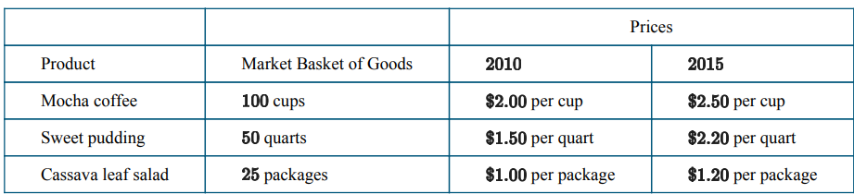
(a) Calculate the cost of the market basket of goods in the table in 2010 and in 2015. Show your work.
(b) Use 2010 as the base year to calculate the price indices for and for the market basket of goods in the table. Show your work.
(c) In order for a citizen of Kona to maintain the same standard of living between 2010 and 2015, what percentage change in nominal income would be needed? Explain
d) If more people in Kona started to consume more sweet pudding, would this have the effect of overstating or understating the effect inflation?
e) If the quality of the Mocha coffee increased over time due to better health standards, would this have the effect of overstating or understating the effect of inflation?

A.
MB2010= (100 x 2) + (50 x 1.50) + (25 x 1)
= 200 + 75 + 25
= 300
MB2015= (100 x 2.5) + (50 x 2.20) + (25 x 1.2)
= 250 + 110 + 30
= 390
B.
CPI₂₀₁₀= (300 / 300) x 100 = 100
CPI₂₀₁₅= (390 / 300) x 100 = 130
c) The inflation rate from 2010 to 2015 is 30% (which we can see easily from the change in CPI from 100 to 130).
Therefore, workers must have an increase in their wages by 30% to have the same standard of living (where they can buy the same amount of goods and services).
d) The basket is not going to include ‘enough pudding’ and so the effect of the increase in price of pudding will be understated. Therefore understate inflation.
e) The basket is going to not going to include the improvement in quality, therefore it will overstate the effects of inflation.

